**PRIYANKA SENGUPTA** 



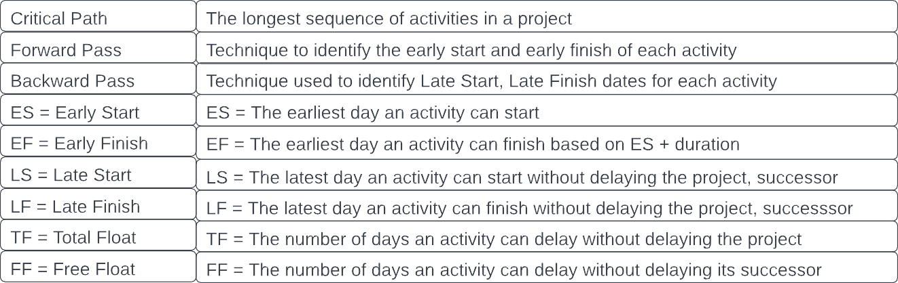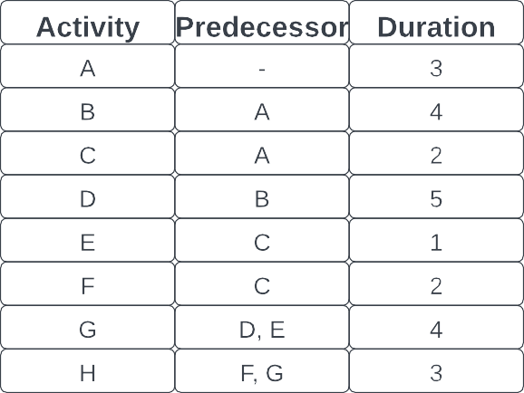



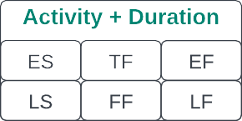

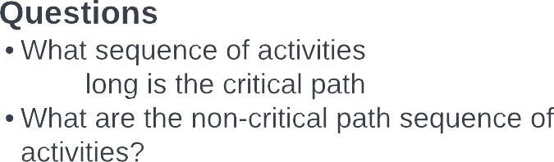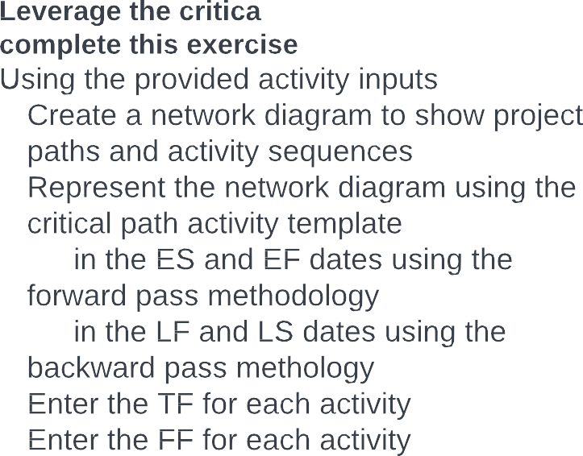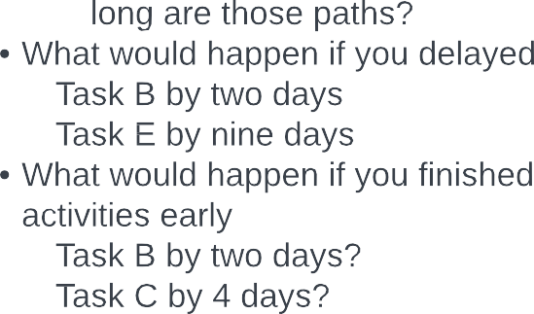

Q1 : Create a Network Diagram to show project Paths and activity sequences.

Q2 Represent the Diagram using Critical Path Template

Q3. Fill in ES and EF dates using Forward Pass Methodology

Q4. Fill in the LS and LF dates using Backward Pass Methodology.

Q5. Fill in the TF for all activities.

Q6. Fill in the FF for all activities.

Q1) What Sequence of activities is the critical Path?

Ans: **Activity A B D G H**

Q2) How long is the Critical Path?

Ans : **A= 3 , B =4, D =5, G=4 , H= 3**

**3+4+5+4 =** **19**

Q3) What are the non-Critical path sequence of activities?

Ans : **A C E G H**

**A C F H**

Q4) How long are those paths?

Ans : **A C E G H : 3 + 2 + 1 + 4 + 3 = 13**

**A C F H : 3 + 2+ 2 + 3 = 10**

**Q5) What would happen if you delayed.**

**Task B by 2 days**

Ans: **As Activity B falls under the Critical path, any delay in the activity could cause the overall project delay. If the activity B is delayed by 2 days then the overall Critical Path Duration would increase by 2 days i.e 19 + 2 = 21**

**Task E by 9 days**

Ans : **Activity E doesn’t fall under critical path; however, it is a predecessor of an activity which falls under critical path. The Free Float for activity is 6 days i.e., the task E could only be delayed by 6 days, If the Task E is delayed by 9 days, the 9-6 = 3 days; the Critical path would be delayed by 3 days and the total Critical path would be 19 + 3 = 22**

**Q6) What would happen if you finished activities early?**

**Task B by 2 days**

**Ans: Task B’s EF is 7 days so if it’s within 7 days it won’t impact the project at any level. If Task B is finished early by 2 days, then the duration of critical path would reduce to 19 – 2 = 17 days.**

**Task C by 4 days**

**Ans:** **Task C ‘s whole duration is 2 only so it is not possible to finish it early by 4 days.**